**Examples of Web Page Hosted:**



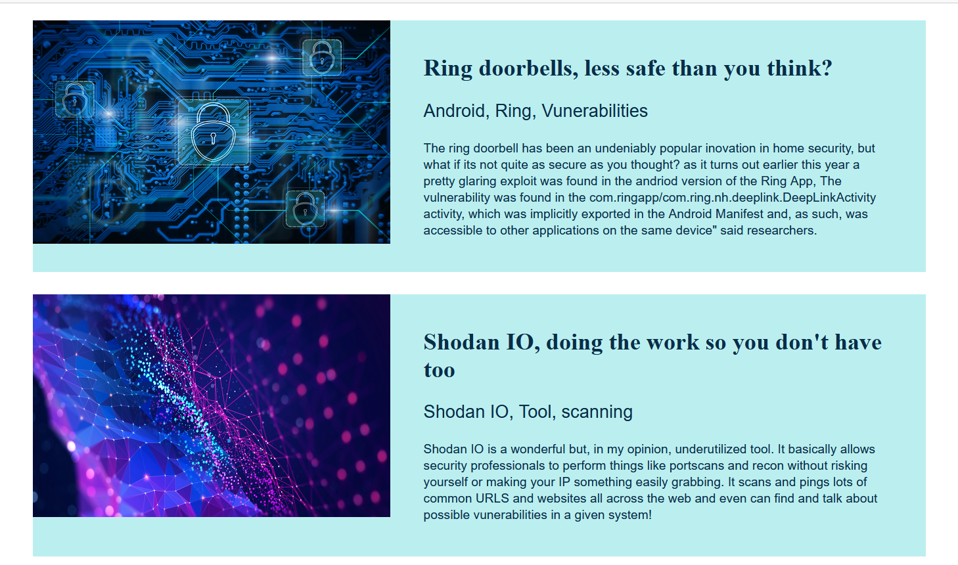

Demonstration of Azure front Door being enabled



WAF Custom Rule Example

